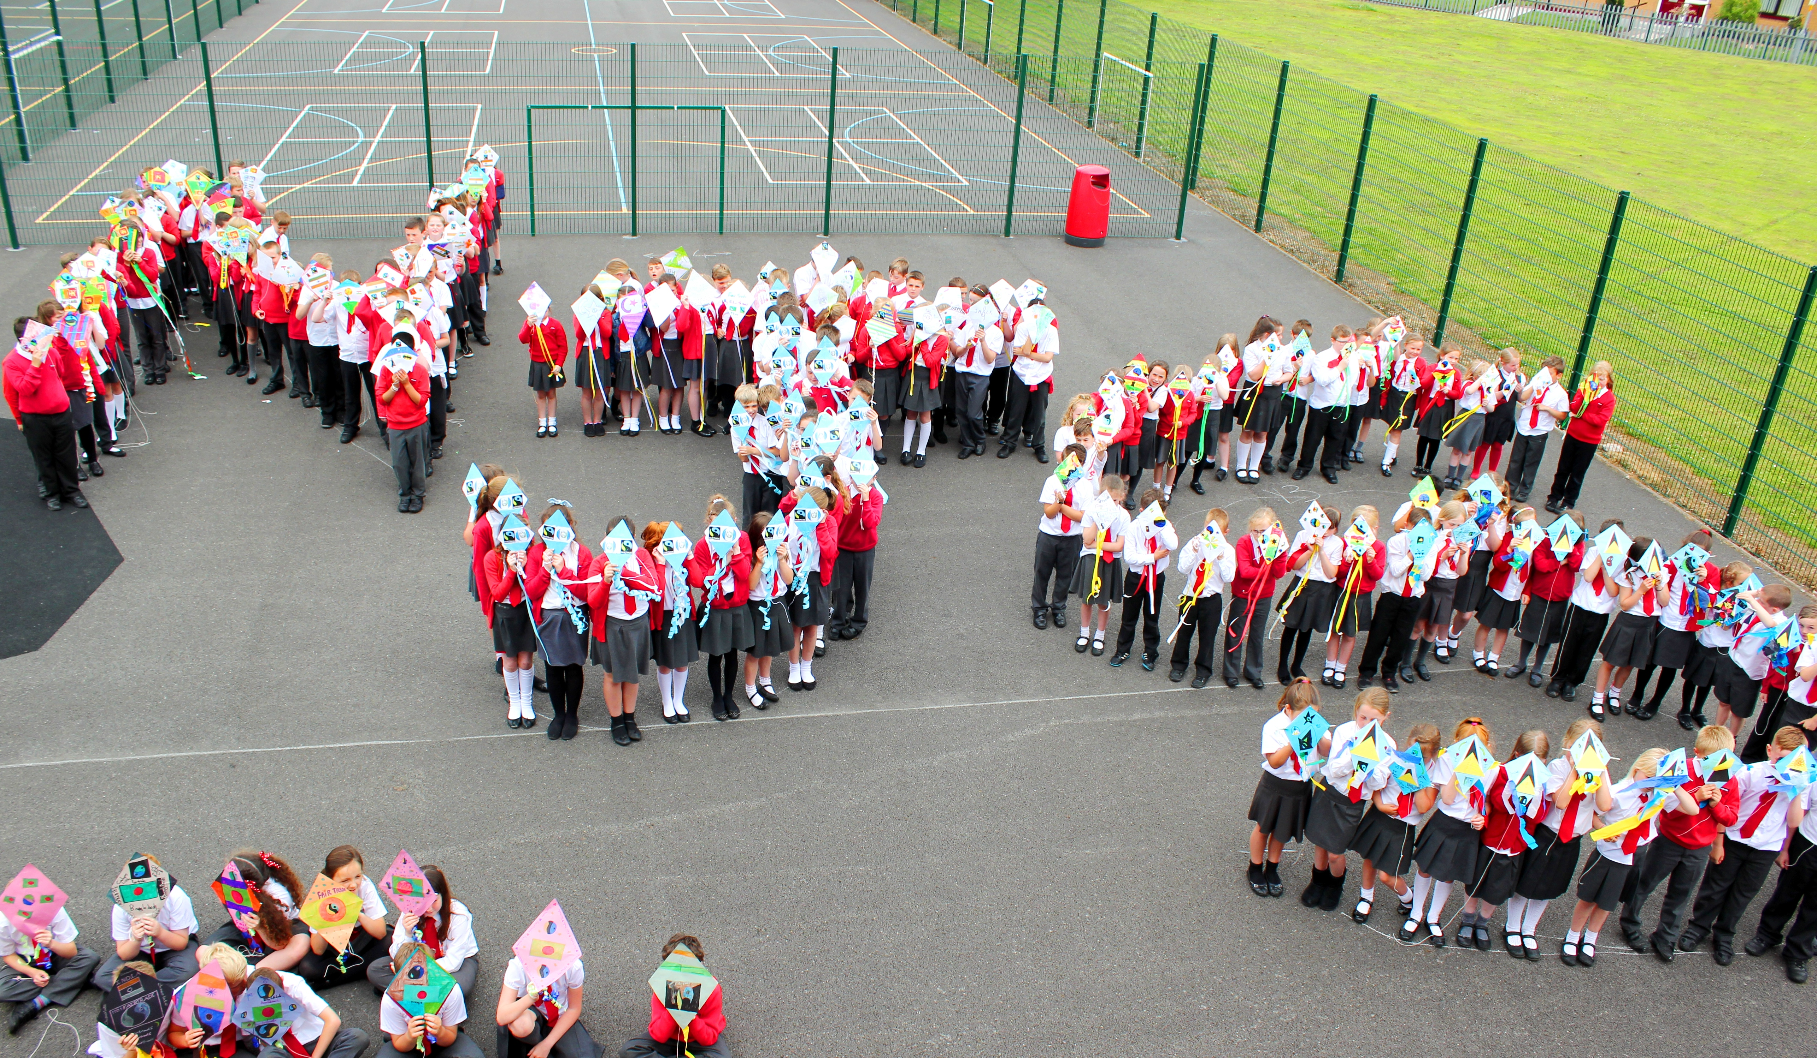

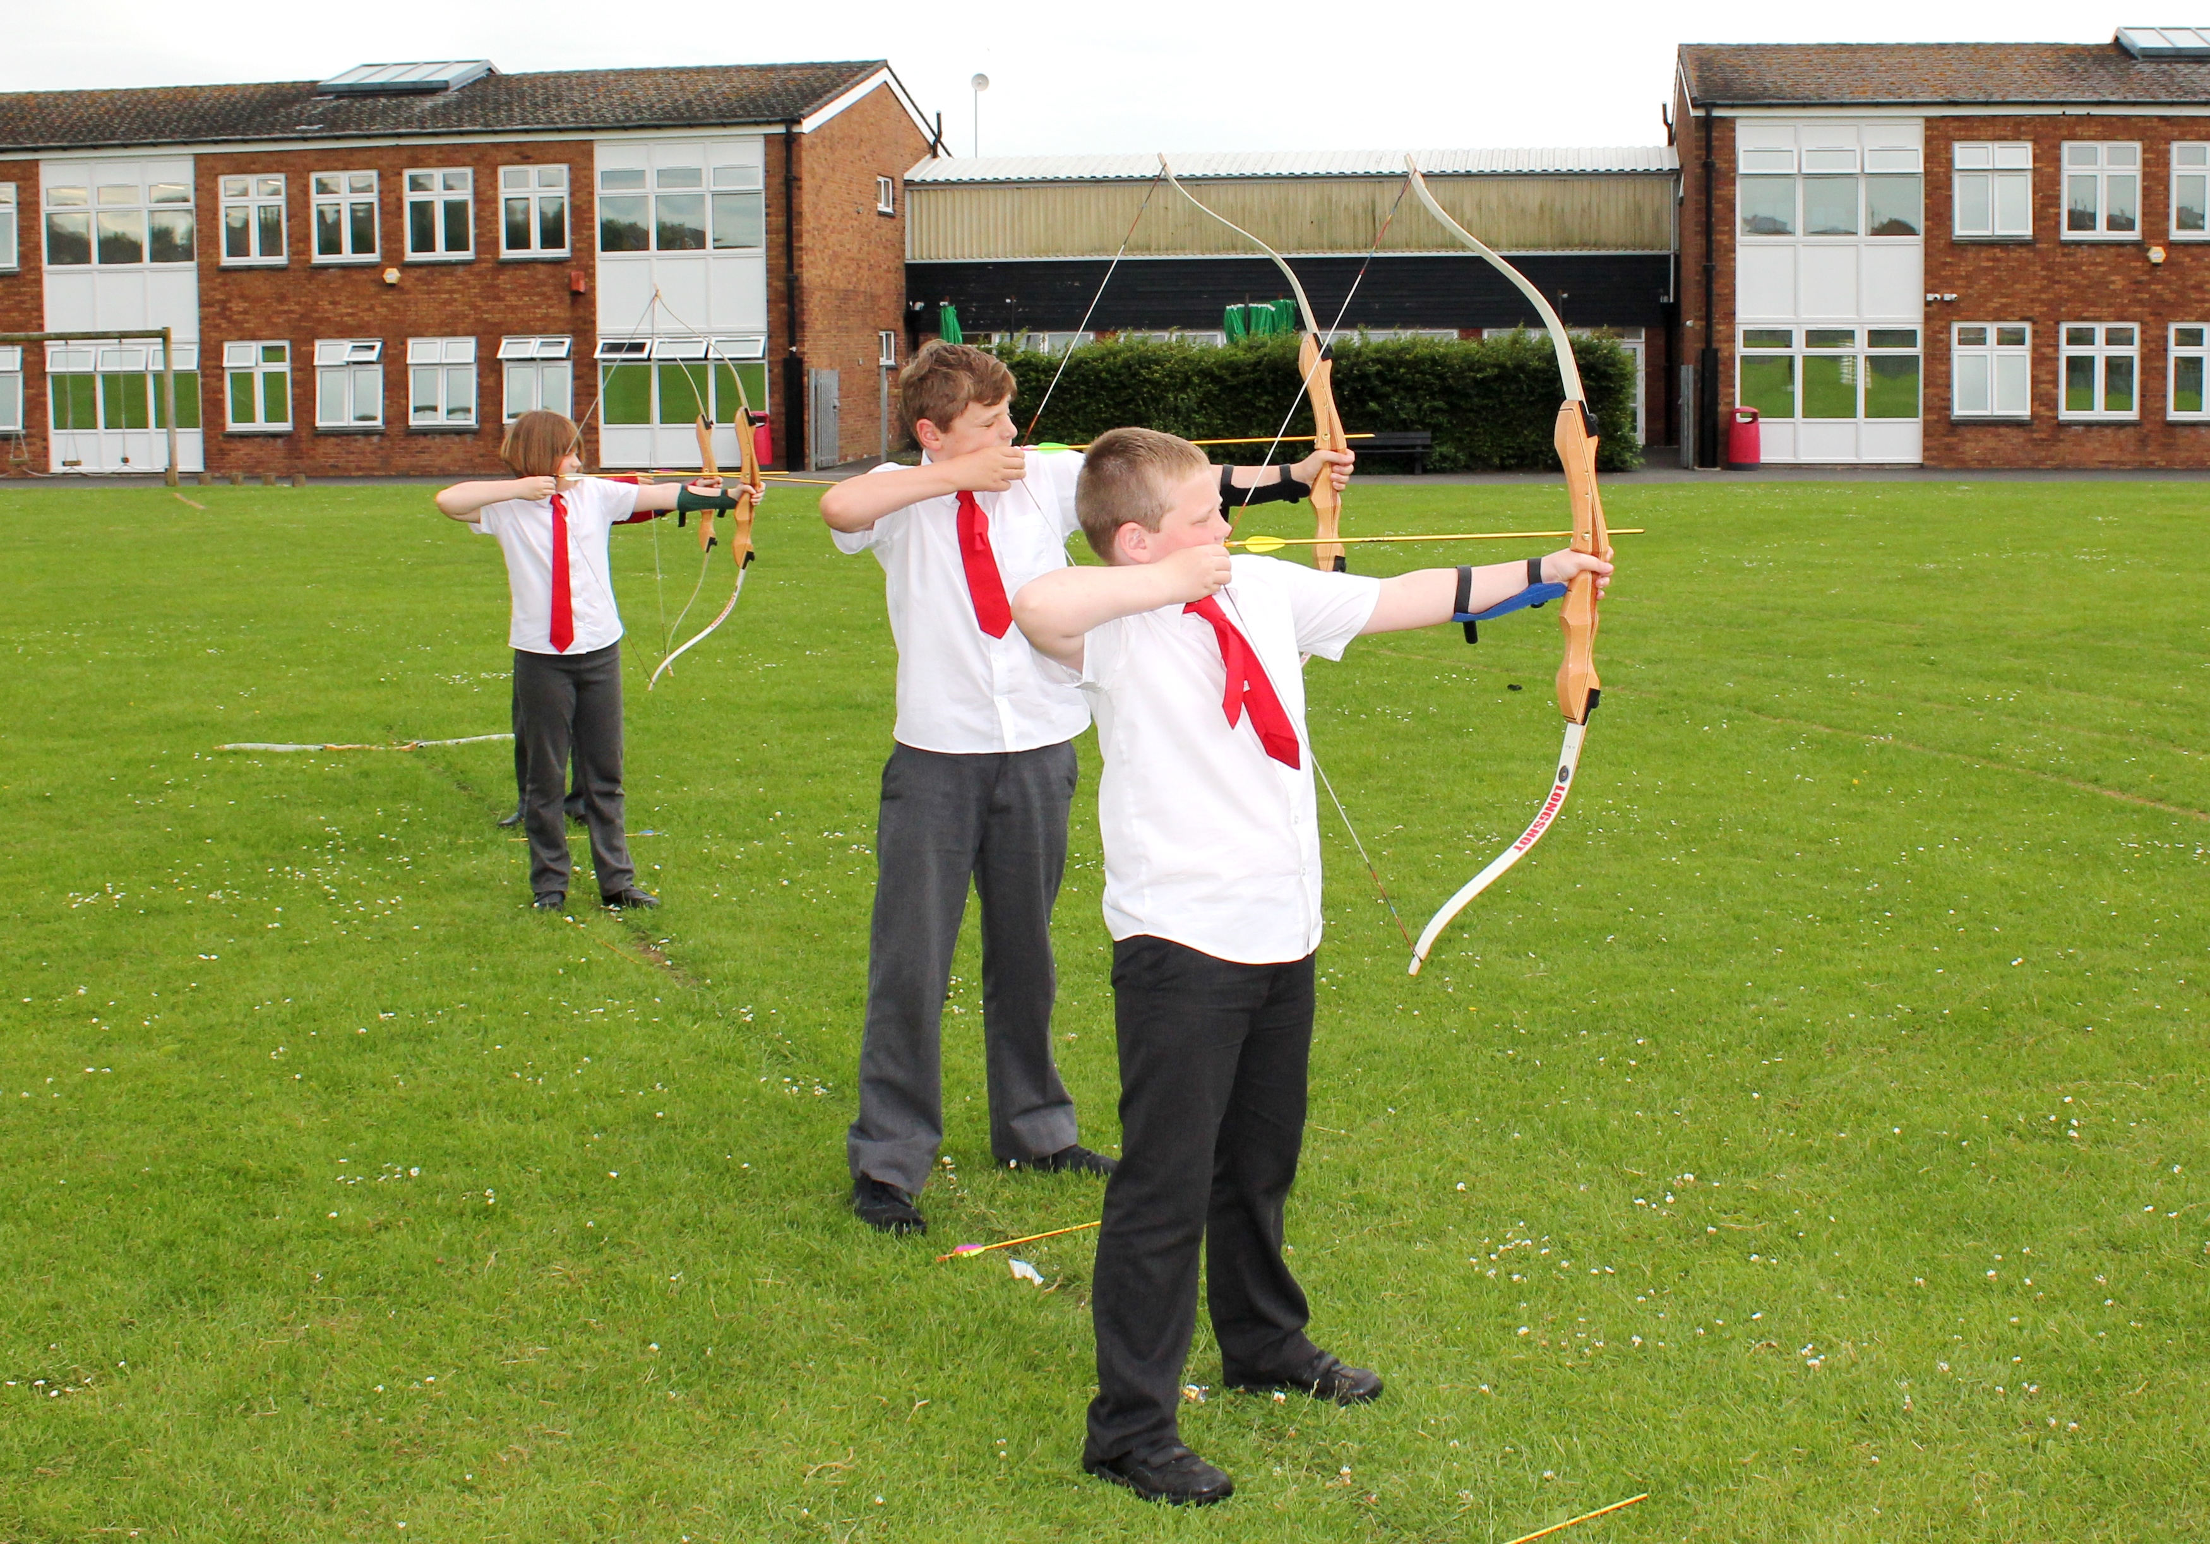
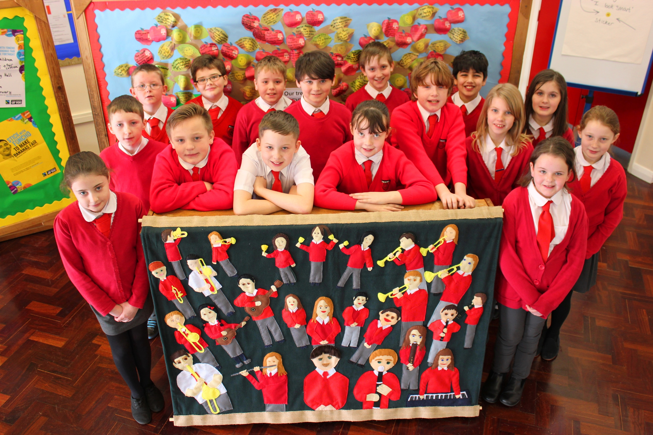


ACTION PLANS 2015-16

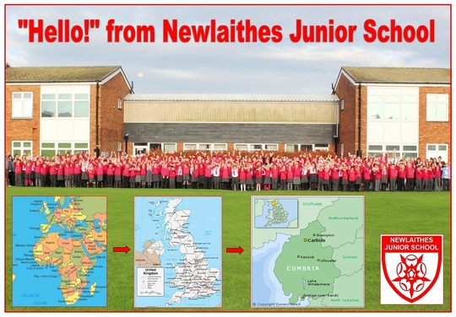
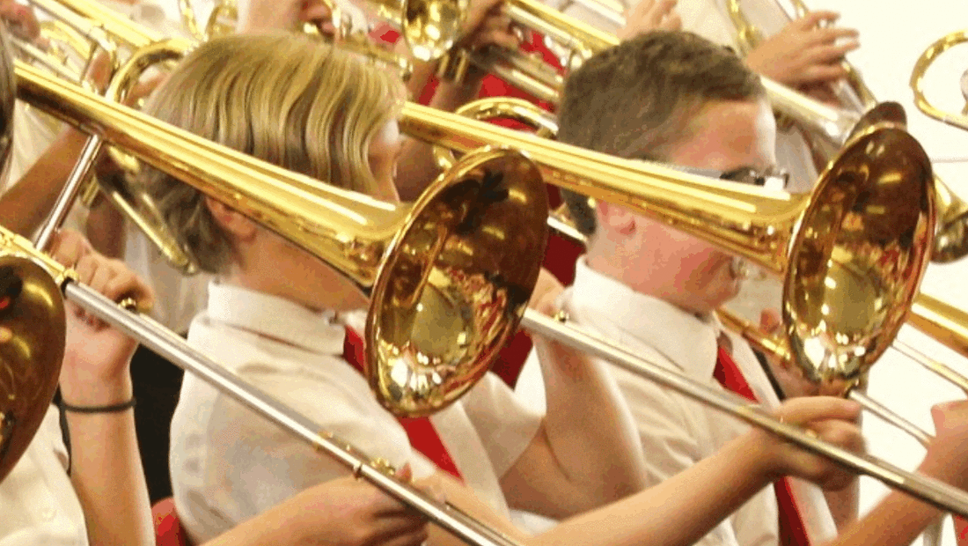

Strategic Priorities for Newlaithes Junior School (2015-18)
- Accelerated development
- Achievement of disadvantaged children
- Sustaining outstanding practise
- Experiential learning (in class, outdoors and locality based)
- Relevance in all learning
- Independence & resilience
- Relationship management
- Parental engagement and partnership
- Suitable working environments

Strategic Goals for Newlaithes Junior School (2015-18)
Standards
In three years time our children will achieve expected or above progress as they transfer to secondary school. Rigorous monitoring will ensure that all children including the identified disadvantaged children, will receive appropriate interventions to enable sustained outstanding learning.

Curriculum
In three years time the curriculum will continue to adapt to provide outstanding learning experiences that apply key skills previously learned by our children. Learning will excite and enthuse children through experiential learning opportunities within the indoor and outdoor learning environments and also using our immediate locality. Children will develop independence and resilience to support their academic and social development; including skills to manage others. Quality professional development for staff will continue to enrich the curriculum.

Parents
In three years time parents will be given opportunities to recognise and develop their role in their child’s development during key stage two. They will also be offered opportunities to support the running and development of our school.

Premises
The building will continue to evolve in order to better accommodate identified need.

Action Planning - governor monitoring deadlines
 | Literacy | Numeracy | Science | Computing | RE | History | Geography | Art | Music | PE | PSHE | SEN | DT | Forest School | Gifted & Talented | French
Sept |  |  |  |  |  |  |  |  |  | 21 Sep 15
October | 12 Oct 15 |  |  | 5 Oct 15 |  |  |  | 19 Oct 15 | 19 Oct 15
November |  | 16 Nov 15 | 30 Nov 15 |  |  |  |  |  |  |  | 9 Nov 15 | 2 Nov 15 | 23 Nov 15 | 9 Nov 15 | 23 Nov 15 | 9 Nov 15
December |  |  |  |  | 14 Dec 15 | 7 Dec 15 | 7 Dec 15
January | 8 Feb 16 |  |  |  |  |  |  |  |  | 18 Jan 16
February |  |  |  | 5 Feb 16 |  |  |  | 22 Feb 16 | 22 Feb 16 |  | 29 Feb 16 |  |  | 29 Feb 16 | 22 Feb 16
March |  | 7 Mar 16 | 21 Mar 16 |  | 14 Mar 16 |  |  |  |  |  |  | 7 Mar 16 |  |  |  | 21 Mar 16
April |  |  |  | 25 Apr 16 |  | 18 Apr 16 | 18 Apr 16 |  |  |  |  |  | 11 Apr 16
May |  |  |  |  |  |  |  | 16 May 16 | 16 May 16 | 2 May 16
June | 20 Jun 16 |  | 27 Jun 16 |  |  |  |  |  |  |  | 13 Jun 16 |  |  |  | 27 Jun 16
July |  | 4 July 16 |  |  | 11 Jul 16 |  |  |  |  |  |  | 4 July 16 | 11 Jul 16

Literacy (Karen Lowther)
- Long Term Aim: By 2018: Each year group will leave our school having progressed beyond the expected levels of progress [HIGHEST STANDARDS].

What do we want to achieve?  What are our priority tasks? | What actions are required? | Leader?  Action Date? | Evaluation of effectiveness |  | Gov  R-A-G | What will be the impact? | Resources  Required?
1. Each year group achieve a minimum of 4.0 APS (or equivalent) development in writing. | a. Monitor progress made termly in each year group, investigating & supporting where targets are not being achieved.  b. Further embed the ‘Creative Curriculum’ to promote writing.  c. Half-termly assessments carried out in line with the new national curriculum.  d. Assessed work is moderated in year groups and across the key stage.  e. Develop and monitor consistency in assessment practices, linking to new developments in end of Key Stage tests.  f. Staff CPD where identified. | Karen Lowther  Wk beg,  5 Oct 15,  1 Jan 16  13 Jun 16 | Literacy Governor  Wk beg,  12 Oct 15  8 Feb 16  20 Jun 16  + HT to report to Gov. termly |  | Aut  ________  Spr  ________  Sum  ________ | - Children appropriately challenged.  - Children able to confidently apply skills learned within extended writing tasks/cross-curricular.  - Consistent development of writing skills across the whole school.  - Consistency in feedback to develop learning.  - Improved tracking of children’s writing ability needs. | £0  AC to cover as required.
2. Each year group achieve a minimum of 4.0 APS (or equivalent) development in reading. | a. Monitor progress made termly in each year group, investigating & supporting where targets are not being achieved.  b. Develop a consistent approach/assessment practices to the teaching and learning taking place within reading in line with the new national curriculum.  c. Monitor the delivery of ‘Guided Reading’ either as part of the Literacy hour or as a separate lesson.  d. Staff CPD where identified.  e. Use Library Loan allocation to enhance ‘Guided Reading’ books available.  f. Continue to fully embed ‘Junior Librarian’ to log/monitor books read. | Karen Lowther  Wk beg,  5 Oct 15,  1 Jan 16  13 Jun 16 |  |  | Aut  ________  Spr  ________  Sum  ________ | - Children appropriately challenged and able to confidently apply awareness of reading to writing tasks.  - Consistency in the development of reading skills across the whole school.  - Enhancement of the ability to confidently apply inference and deduction skills across the curriculum.  - Improved tracking of children’s reading ability/needs. | £0  AC to cover as required.
What do we want to achieve?  What are our priority tasks? | What actions are required? | Leader?  Action Date? | Evaluation of effectiveness |  | Gov  R-A-G | What will be the impact? | Resources  Required?
3. Monitoring indicates consistently good or better standards of learning. | a. 1 lesson in aut and spr is observed with a focus upon:  - context & relevance (incl. cross curricular links/ICT);  - challenge & expectations;  - use of learning styles;  - application of skills; and  - Guided Reading.  b. Pupil interviews.  c. KL to report to AC, and feedback & work with staff to develop their practice further.  d. Monitoring of work – book scrutiny – to take place in autumn, spring and summer.  e. Children are fully confident and articulate when applying literacy skills in other subjects.  f. In reading and writing, targets are fully embedded to focus upon identified need.  g. 1x work scrutiny per term of all children’s literacy work will focus upon:  - Differentiation  - Progression  - Marking  - Presentation  - AfL  - Expectations  - Cross-curricular links  h. KL to report to AC, and feedback & work with staff to develop their practice further (CPD). | Karen Lowther  Wk beg,  5 Oct 15,  1 Feb 16  13 Jun 16 | Literacy Governor  Wk beg,  12 Oct 15  8 Feb 16  20 Jun 16  + HT to report to Gov. termly |  | Aut  ________  Spr  ________  Sum  ________ | - Children challenged to learn to the best of their ability.  - Supportive feedback to staff to further develop their effectiveness.  - Standards will be sustained at  good or better.  - Children are appropriately  challenged and able to  confidently apply skills taught  within the wider curriculum.  - Sharing best practice.  - Feedback develops understanding/learning.  - Children are aware of their progress towards their own individual targets in reading and writing.  - Consistency in self assessment approaches.  - Children are appropriately challenged and able to confidently apply skills taught within the wider curriculum.  - CPD opportunities where required. | £0  AC to cover as required.
What do we want to achieve?  What are our priority tasks? | What actions are required? | Leader?  Action Date? | Evaluation of effectiveness |  | Gov  R-A-G | What will be the impact? | Resources  Required?
4. Monitor and further develop ‘Letters and Sounds’ provision across the key stage. | a. Continue to implement the ‘Letters & Sounds’ programme in all year groups.  b. Ensure all new staff are appropriately trained.  c. Children to be appropriately identified using both informal/formal assessment data available.  d. 1 hour session per week carried out for each identified group by a trained Teaching Assistant. | Lindsey Boyd  supported by Karen Lowther  Wk beg,  5 Oct 15,  1 Feb 16  13 Jun 16 |  | Literacy Governor  Wk beg,  12 Oct 15  8 Feb 16  20 Jun 16 | Aut  ________  Spr  ________  Sum  ________ | - Children given appropriate support to be able to more confidently apply awareness of phonics/spelling rules to spelling/writing/reading tasks.  - Consistency in the development and application of phonics skills across the whole school.  - Enhancement of the ability to confidently apply  skills taught across the  curriculum.  - Improved tracking of children’s ability/needs. | £0
5. Begin to Implement/devise a tracking system to show whether pupils are on track to meet the end of key stage expectations in line with the new national curriculum. | a. Attend relevant CPD.  b. Link to i-track. | Karen Lowther  Wk beg,  5 Oct 15,  1 Feb 16  13 Jun 16 |  | Literacy Governor  Wk beg,  12 Oct 15  8 Feb 16  20 Jun 16 | Aut  ________  Spr  ________  Sum  ________ | - Clear progression of skills being taught across the key stage.  - Children appropriately challenged. | £0
6. Develop handwriting in line with the Nelson Handwriting Scheme. | a. Consult with infant school.  b. Implement a handwriting policy.  c. Update resources.  d. Minimum entitlement of weekly handwriting lesson, carried across into all curricular areas.  e. In-house training/support. | Karen Lowther  Wk beg,  5 Oct 15,  1 Feb 16  13 Jun 16 |  | Literacy Governor  Wk beg,  12 Oct 15  8 Feb 16  20 Jun 16 | Aut  ________  Spr  ________  Sum  ________ | - Clear progression of skills being taught across the key stage.  - Children appropriately challenged. | £2000
Long Term Aim: To enhance the resources available to fully support and develop this curricular area.
What do we want to achieve?  What are our priority tasks? | What actions are required? | Leader?  Action Date? | Evaluation of effectiveness |  | Gov  R-A-G | What will be the impact? | Resources  Required?
7. Audit resources. | a. Maintain provision of library stock.  b. Maintain the management structure for the library based around a set of trained librarians. (Retrain new cohort in summer term.)  c. Ensure dictionaries and thesauruses are up-to-date. | Karen Lowther  Wk beg,  13 Jun 16 | Literacy Governor  Wk beg,  20 Jun 16 |  | Aut  ________  Spr  ________  Sum  ________ | - Children may access quality reading material to enrich their learning whatever their ability.  - Clear progression of skills being taught across the key stage.  - Children appropriately challenged. | £600  Junior Librarian  (+ Library Service to carry out a day removing old books)  £1000
Long Term Aim: Higher ability children are given an appropriate level of challenge.
8. Practice is further embedded to ensure that more able children receive appropriate levels of challenge. | a. More able are identified from data analysis and closely tracked.  b. Monitoring of appropriate challenge is given to these children in all lessons.  c. Cross-curricular links are further established to develop/embed skills taught. | Emily Wilkinson  supported by Karen L  Wk beg,  5 Oct 15,  1 Feb 16  13 Jun 16 | Literacy Governor  Wk beg,  12 Oct 15  8 Feb 16  20 Jun 16 |  | Aut  ________  Spr  ________  Sum  ________ | - Children challenged to learn to the best of their ability. | £0  AC to cover as required.
Long Term Aim: Quality learning environments effectively support learning.
9. Classrooms change and evolve to support current learning. | a. Literacy Learning Wall is evident to support current teaching incl. necessary prompts for children’s learning.  b. Vibrant, neat, tidy and clearly labelled classrooms support, encourage and challenge learning.  c. Displays are updated half-termly/ termly in line with Learning Environment policy – to support learning.  d. Half termly general report to staff. | Emily Wilkinson  Wk beg.  5Oct 15,  23 Nov 15 | Literacy Governor  Wk beg,  12 Oct 15 |  | Aut  ________ | - Shared understanding of issues/good practice.  - Children provided with a stimulating environment in which to learn. | £0  NB  Resources from class capitations
9. Classrooms change and evolve to support current learning. |  | 1Feb 16,  14 Mar 16 | 8 Feb 16 |  | Spr  ________ |  | £0  NB  Resources from class capitations
9. Classrooms change and evolve to support current learning. |  | 25 Apr 16,  6 Jun 16 | 20 Jun 16 |  | Sum  ________ |  | £0  NB  Resources from class capitations

Total required for completing actions: £3600
Numeracy (Lindsey Boyd)
- Long Term Aim: Pupil progress and learning is appropriate and rigorously monitored for each year group.

What do we want to achieve?  What are our priority tasks? | What actions are required? |  | Leader?  Action Date? |  | Evaluation of effectiveness |  | Gov  R-A-G | What will be the impact? | Resources  Required?
1. Each year group achieve a minimum of 4 APS development in mathematics. | a. Termly assessments completed.  b. Termly monitoring of work with a focus on continuity and progression in order to raise standards across all ability groups.  c. Identify if differentiation is effective by monitoring rigorously (planning and lessons/learning).  d. Oversee and support the development of interventions.  e. Continue to gather school data termly, analysing it for focus upon pupils or groups in order to maintain consistent expectations in all classes & raise standards further.  f. Use tracking data to inform interventions. |  | Lindsey Boyd  Wk beg.  9 Nov 15  29 Feb 16  27 Jun 16 |  | Numeracy Governor  Wk beg.  16 Nov 15  7 Mar 16  4 Jul 16 |  | Aut  ________  Spr  ________  Sum  ________ | - Children provided with a stimulating environment in which to learn.  - Children appropriately challenged and able to confidently apply skills taught within problem solving activities.  - Consistent development and application of mathematics skills to other curriculum areas when appropriate.  - Consistency across the key stage. |  | Leader-ship time, SLT & staff meetings.  AC to cover as required
2. Cross curricular links using Maths are identified and strengthened. | a. Identify areas of each year group’s topics which will link to Maths objectives  b. Maths focus days/week to be re- established.  c. Superchoice activities to be identified. |  | Wk beg.  27 Jun 16 |  | Wk beg.  4 Jul 16 |  | Sum  ________ | - Key Skills taught are applied throughout the curriculum to develop relevance and retention |  | £250 resources for focus days and activities (from existing Maths and Super-choice budgets)
What do we want to achieve?  What are our priority tasks? | What actions are required? |  | Leader?  Action Date? |  | Evaluation of effectiveness |  | Gov  R-A-G | What will be the impact? |  | Resources  Required?
3. Monitoring indicates consistently good or better standards of learning. | a. 1 lesson in aut and spr is observed with a focus upon:  - context & relevance (incl. cross curricular links/ICT);  - challenge & expectations;  - use of learning styles;  - application of skills; and  - Guided Reading.  b. Pupil interviews.  c. LB to report to AC, and feedback & work with staff to develop their practice further.  d. Monitoring of work – book scrutiny – to take place in autumn, spring and summer.  e. Children are fully confident and articulate when applying numeracy skills in other subjects.  f. Targets are fully embedded to focus upon identified need.  g. 1x work scrutiny per term of all children’s numeracy work will focus upon:  - Differentiation  - Progression  - Marking  - Presentation  - AfL  - Expectations  - Cross-curricular links  h. LB to report to AC, and feedback & work with staff to develop their practice further (CPD). |  | Lindsey Boyd  Wk beg.  9 Nov 15  29 Feb 16  27 Jun 16 |  | Numeracy  Governor  Wk beg.  16 Nov 15  7 Mar 16  4 Jul 16 |  | Aut  ________  Spr  ________  Sum  ________ | - Children challenged to learn to the best of their ability.  - Supportive feedback to staff to further develop their effectiveness.  - Standards will be sustained at  good or better.  - Children are appropriately  challenged and able to  confidently apply skills taught  within the wider curriculum.  - Sharing best practice.  - Children are appropriately challenged.  - Feedback develops understanding/learning.  - Supportive feedback to staff to further develop their effectiveness.  - Children are aware of their progress towards their own individual targets.  - Consistency in self assessment approaches.  - Children are appropriately challenged and able to confidently apply skills taught within the wider curriculum.  - CPD opportunities where required. |  | £0  AC to cover as required.
Long Term Aim: CPD -Support the training needs of class teachers and TAs
What do we want to achieve?  What are our priority tasks? | What actions are required? |  | Leader?  Action Date? |  | Evaluation of effectiveness |  | Gov  R-A-G | What will be the impact? |  | Resources  Required?
4. All class teachers have sufficient knowledge and understanding to achieve good or better standards of learning in the children they teach. | a. LB to provide opportunities to share ideas and good practice.  b. LB to ensure feedback from all numeracy courses during staff meetings.  c. LB to provide inset to share updates.  d. LB & staff to attend appropriate courses related to performance management and school development needs.  e. Networking with neighbouring schools, termly meetings. |  | Lindsey Boyd  Wk beg.  27 Jun 16 |  | Numeracy Governor  Wk beg.  4 Jul 16 |  | Aut  ________  Spr  ________  Sum  ________ | - Stimulating high quality teaching is given to all children.  - Ideas are shared ideas to promote creativity and progression.  - Networking opportunities will lead to widening of experiences and sharing of good practice. |  | £1000
Long Term Aim: Quality resourcing and quality learning environments effectively support learning.
5. Audit of practical equipment and all teaching resources, including ICT. |  | a. Audit of practical equipment and maths learning and teaching resources. Purchase resources to support differentiation.  b. Purchase/ subscribe to Mathletics and My Maths to support individual learners to overcome barriers.  c. Ensure common methods are in use.  d. All teachers have:  - Prompts for children’s learning  - Working walls  - Vibrant, neat, tidy and clearly labelled classrooms . |  | Lindsey Boyd  Wk beg.  29 Feb 16 |  | Numeracy Governor  Wk beg.  4 Jul 16 | Aut  ________  Spr  ________  Sum  ________ |  |  |  | £1800 inc purchase of Mathletics and My Maths

Total required for completing actions: £2050 + £1000 CPD

Science (Janet Dewhurst)
- Long Term Aim: To further develop the effectiveness of science throughout the school.
What do we want to achieve?  What are our priority tasks? | What actions are required? |  | Leader?  Action Date? | Evaluation of effectiveness | Gov  R-A-G | What will be the impact? | Resources
1. Monitoring indicates consistently good or better standards of learning. | a. Science co-ordinator to carry out work scrutiny in autumn, spring and summer terms.  b. Focus on:  - Differentiated work and activities;  - Use of outdoor environment;  - Working Scientifically (investigations) | JD  Wk beg.  23 Nov 15,  14 Mar 16  20 Jun 16 |  | Science Governor  Wk beg.  30 Nov 15,  21 Mar 16  27 Jun 16 | Aut  ________  Spr  ________  Sum  ________ | - Standards in sciences with be at least good or better. | £0
2. All class teachers have sufficient knowledge and understanding to achieve good or better standards of learning in the children they teach. | a. Science co-ordinator to attend CSP (Carlisle Schools Partnership) meetings termly.  b. Science coordinator to establish areas of weakness from monitoring, source appropriate CPD for staff and organise training (in liaison with KL). | JD  Wk beg.  23 Nov 15,  14 Mar 16  20 Jun 16 |  | Science Governor  Wk beg.  30 Nov 15,  21 Mar 16  27 Jun 16 | Aut  ________  Spr  ________  Sum  ________ | - All staff achieve good or better levels of teaching and learning in their class. | £1000
3. To identify appropriate end of year / topic tests for parity in years 3, 4 and 5. | a. Source examples of assessment tests currently available of the market  b. Consult with staff, trial as necessary and agree - then purchase. | JD  Wk beg.  23 Nov 15,  14 Mar 16  20 Jun 16 |  | Science Governor  Wk beg.  30 Nov 15,  21 Mar 16  27 Jun 16 | Aut  ________  Spr  ________  Sum  ________ | - Assessments will more accurately reflect learning and fit in with new curriculum.  - Consistency across school. | £500
4. Resources are appropriate to the school requirements and suitably stored | a. Audit current resources, with the school science curriculum in mind; including storage for science equipment & resources for outdoor learning.  b. Create a proposal to upgrade the science cupboard and develop outdoor learning in science (including costs) and present to HT.  c. Consult staff for any additional resourcing requirements.  d. Check catalogues/websites for best value and place orders. | JD  Wk beg.  23 Nov 15,  14 Mar 16  20 Jun 16 |  | Science Governor  Wk beg.  30 Nov 15,  21 Mar 16  27 Jun 16 | Aut  ________  Spr  ________  Sum  ________ | - Staff will be able to access all required resources to apply engaging science curriculum. | £1000
Total required for completing actions: £1500 + £1000 CPD
Computing (Simon Clarke)
- Long Term Aim: The development of an efficient computing curriculum
What do we want to achieve?  What are our priority tasks? | What actions are required? | Leader?  Action Date? | Evaluation of effectiveness | Gov  R-A-G |  | What will be the impact? | Resource
1. Appropriate staff skills and resources allow computing skills to be good or better. | a. Audit staff skills and each classroom for equipment to establish and develop provision (with a focus upon the use of netbooks).  b. Termly work scrutiny establishes use of ICT skills throughout the curriculum and judges the quality of this work as outstanding, good, requires improvement or inadequate.  c. Through inset and staff meetings, teach and revise ICT skills with class teachers to ensure they have sufficient knowledge and understanding to achieve good or better standards of learning in the children they teach.  d. Discuss costs of training & purchases with HT, then place orders. | S Clarke  Wk beg.  28 Sept 15  25 Jan 16  18 Apr 16 | ICT Governor  Wk beg.  5 Oct 15  1 Feb 16  25 Apr 16 | Aut  ________  Spr  ________  Sum  ________ | - ICT provision (teaching, learning and equipment) is at least good or better. |  | £5000
2. Develop video coaching in the PE curriculum. | a. Purchase a class tablet for each class, capable of recording video.  b. Train the staff, using archery as an example, on how to use video footage as a coaching aid to better technique. | S Clarke  Wk beg.  28 Sept 15  25 Jan 16  18 Apr 16 | CT Governor  Wk beg.  5 Oct 15  1 Feb 16  25 Apr 16 | Aut  ________  Spr  ________  Sum  ________ | - Video coaching enhances learning in PE. |  | Sports Funding (£2400)
3. Establish whether an electronic voting system would be value for money within school. | a. Look at how a voting system could be used within school.  b. Investigate appropriate packages including staff training. | S Clarke  Wk beg.  25 Jan 16 | CT Governor  Wk beg.  25 Apr 16 | Aut  ________  Spr  ________  Sum  ________ | - Cross curricular assessment through the use of ICT with minimal staff time required. |  | £3000
Total required for completing actions: £10,400 incl Sports Premium funding
Religious Education (Janet Dewhurst)
- Long Term Aim: To further develop the effectiveness of the RE curriculum and the SMSC coverage throughout the school.
What do we want to achieve?  What are our priority tasks? | What actions are required? | Leader?  Action Date? | Evaluation of effectiveness | Gov  R-A-G | What will be the impact? | Resource
1. Monitoring indicates consistently good or better standards of learning. | a. RE co-ordinator carry out book scrutinies in autumn, spring and summer terms.  b. The impact of Social, Moral, Spiritual and Cultural (SMSC) teaching and learning is evaluated, including assemblies (with support from Bev Bell). | JD  Wk beg.  7 Dec 15  7 Mar 16  4 Jul 16 | RE Governor  Wk beg.  14 Dec 15  14 Mar 16  11 Jul 16 | Aut  ________  Spr  ________  Sum  ________ | - Standards in RE and SMSC are judged and where required, support and training is given. | £0
2. All class teachers have sufficient knowledge and understanding to achieve good or better standards of learning in the children they teach. | a. RE co-ordinator to attend CSP (Carlisle Schools Partnership) meetings termly.  b. RE & SMSC coordinators to establish areas of weakness from monitoring, source appropriate CPD for staff and organise training (in liaison with KL). | JD  Wk beg.  7 Dec 15  7 Mar 16  4 Jul 16 | RE Governor  Wk beg.  14 Dec 15  14 Mar 16  11 Jul 16 | Aut  ________  Spr  ________  Sum  ________ | - Standards in RE and SMSC are judged to be good or better. | £600
3. Resources are appropriate to our curriculum offer. | a. Check current resources.  b. Offer suitable resources / ask staff to suggest required items.  c. Check catalogue/web sites.  d. Place orders. | JD  Wk beg.  7 Dec 15  7 Mar 16  4 Jul 16 | RE Governor  Wk beg.  14 Dec 15  14 Mar 16  11 Jul 16 | Aut  ________  Spr  ________  Sum  ________ | - Appropriate resourcing supports good or better standards in RE and SMSC. | £300
4. Enhance the curriculum offer in RE and SMSC through the use of invited visitors into school and visits. | a. Use contacts with NISCU and local churches.  b. Check availability of Bibleworld for Y4.  c. Enquire about contacts with other faith groups and cultures.  d. Continue to build links with Jack and Jill School in Zambia (Andrew).  e. Link to Fair Trade activities (Jo). | JD  Wk beg.  7 Dec 15  7 Mar 16  4 Jul 16 | RE Governor  Wk beg.  14 Dec 15  14 Mar 16  11 Jul 16 | Aut  ________  Spr  ________  Sum  ________ | - Children will have the opportunity to question and experience first-hand believers from faith groups and people from other cultures. | £0
Total required for completing actions: £300 + £600 CPD
History (Natalie Kay)
Long Term Aim: To further develop the effectiveness of the History curriculum throughout the school.
What do we want to achieve?  What are our priority tasks? | What actions are required? | Leader?  Action Date? | Evaluation of effectiveness | Gov  R-A-G | What will be the impact? | Resource
1. Appropriate staff skills and resources ensure history knowledge and skills are good or better. | a. Audit staff skills takes place to establish and develop provision.  b. Audit of resources in each year group takes place to establish and develop appropriate coverage across the school.  c. Two work scrutiny’s establishes levels of coverage, quality and quantity and differentiation and provides developmental feedback to class teachers.  d. Training opportunities are sought and offered to staff, especially where a need has been identified. | NK  Wk beg.  30 Nov 15  11 Apr 16 | History Governor Wk beg.  7 Dec 15  18 Apr 16 | Aut  ________  Sum  ________ | - Standards in history are assessed and where required, support and training is provided. | £500
2. Each year group looks closely at their field visit opportunities to make sure that they are still appropriate and relevant to the new curriculum. | a. New opportunities outside of school are identified and suggested to staff.  b. Specialists (individuals and organisations) are invited into school to enhance learning.  c. The staff spend time deciding upon and planning focused events with a History theme for the whole school. | NK  Wk beg.  30 Nov 15  11 Apr 16 | History Governor  7 Dec 15  18 Apr 16 | Aut  ________  Sum  ________ | - More hands on experience for children about their given topic.  - A more in depth and thorough understanding of their topic.  - More opportunities for cross curricular links and learning. | £250
3. History Subject Leader is up knowledgeable, maintains a subject leader file and assists with future development of History. | a. CPD for subject leader is established locally (e.g. CSP group) and through external training.  b. Following guidance from school documentation (e.g. handbook for teachers) and other subject leaders, files and necessary evidence are maintained in a uniform format. | NK  Wk beg.  30 Nov 15  11 Apr 16 | History Governor  7 Dec 15  18 Apr 16 | Aut  ________  Sum  ________ | - Training for subject leader is effective in developing skills.  - Subject Leader File is up to date and supports future development. | £250
Total required for completing actions: £500 + £500 CPD

Geography (Roxanna MaCartney)
Long Term Aim: To further develop the effectiveness of the Geography curriculum throughout the school.
What do we want to achieve?  What are our priority tasks? | What actions are required? | Leader?  Action Date? | Evaluation of effectiveness | Gov  R-A-G | What will be the impact? | Resources  Required?
1. Appropriate staff skills and resources ensure geography knowledge and skills are good or better. | a. Audit staff skills takes place to establish and develop provision.  b. Audit of resources in each year group takes place to establish and develop appropriate coverage across the school.  c. Two work scrutiny’s establishes levels of coverage, quality and quantity and differentiation and provides developmental feedback to class teachers.  d. Training opportunities are sought and offered to staff, especially where a need has been identified. | RM  Wk beg.  30 Nov 15  11 Apr 16 | geography Governor  7 Dec 15  18 Apr 16 | Aut  ________  Sum  ________ | - Standards in geography are assessed and where required, support and training is provided. | £500
2. Each year group looks closely at their field visit opportunities to make sure that they are still appropriate and relevant to the new curriculum. | a. New opportunities outside of school are identified and suggested to staff.  b. Specialists (individuals and organisations) are invited into school to enhance learning.  c. The staff spend time deciding upon and planning focused events with a geography theme for the whole school. | RM  Wk beg.  30 Nov 15  11 Apr 16 | geography Governor  7 Dec 15  18 Apr 16 | Aut  ________  Sum  ________ | - More hands on experience for children about their given topic.  - A more in depth and thorough understanding of their topic.  - More opportunities for cross curricular links and learning. | £250
3. geography Subject Leader is up knowledgeable, maintains a subject leader file and assists with future development of geography. | a. CPD for subject leader is established locally (e.g. CSP group) and through external training.  b. Following guidance from school documentation (e.g. handbook for teachers) and other subject leaders, files and necessary evidence are maintained in a uniform format. | RM  Wk beg.  30 Nov 15  11 Apr 16 | geography Governor  7 Dec 15  18 Apr 16 | Aut  ________  Sum  ________ | - Training for subject leader is effective in developing skills.  - Subject Leader File is up to date and supports future development. | £250
Total required for completing actions: £500 + £500 CPD
Art (Emily Wilkinson)
- Long Term Aim: To develop the Art curriculum throughout the school
What do we want to achieve?  What are our priority tasks? | What actions are required? | Leader?  Action Date? |  | Evaluation of effectiveness | Gov  R-A-G | What will be the impact? |  | Resources  Required?
1. CPD is identified for teachers. | a. Expectations in art are clarified with class teachers, so they know what outstanding practice looks like.  b. Art work is monitored termly in each class and where weaknesses are discovered, appropriate advice and CPD is sourced for staff.  c. Identify general areas for development (audit linked to progression of skills); source CPD and organise. | EW  Wk beg.  12 Oct 15  8 Feb 16  9 May 16 |  | Art Governor  Wk beg.  19 Oct 15  22 Feb 16  16 May 16 | Aut  ________  Spr  ________  Sum  ________ | - Appropriate CPD is provided to support class teachers. |  | £600
2. CPD is undertaken and evaluated with a focus upon outstanding teaching and learning in art. | a. Following CPD, teaching of art is monitored by observation/collection of evidence (the term after CPD).  b. The effectiveness of CPD (linked to teaching and learning of art) is reported to staff and governors. | EW  Wk beg.  8 Feb 16  9 May 16 |  | Art Governor  Wk beg.  22 Feb 16  16 May 16 | Spr  ________  Sum  ________ | - CPD has impact on teaching and learning.  - Impact is reported to staff and governors. |  | £0
3. The Arts mark is gained. | a. Evidence collated and application completed. | EW  Wk beg.  12 Oct 15  8 Feb 16  9 May 16 |  | Art Governor  Wk beg.  19 Oct 15  22 Feb 16  16 May 16 | Aut  ________  Spr  ________  Sum  ________ | - Arts mark awarded. |  | £0
4. Opportunities are identified to use the outdoors to enhance learning. | a. Meet class teachers to identify opportunities to use outside areas.  b. Create a timetable of these opportunities.  c. Monitor and evaluate the impact of these opportunities and report to staff and governors. | EW  Wk beg.  12 Oct 15  8 Feb 16  9 May 16 |  | Art Governor  Wk beg.  19 Oct 15  22 Feb 16  16 May 16 | Aut  ________  Spr  ________  Sum  ________ | - Planning includes the use of outdoor spaces to enhance learning.  - Outdoor areas are planned for and evaluated.  - Impact is reported to staff and governors. |  | £0
What do we want to achieve?  What are our priority tasks? | What actions are required? | Leader?  Action Date? |  | Evaluation of effectiveness | Gov  R-A-G | What will be the impact? |  | Resources  Required?
5. Specialists are identified to support learning. | a. Opportunities to use specialist art teachers are identified, sourced and costed to support staff and children’s learning.  b. Specialists support staff on focused CPD.  children’s learning .  c. Specialists work with children on art based project(s), producing outstanding artwork to inspire other children. | EW  Wk beg.  12 Oct 15  8 Feb 16  9 May 16 |  | Art Governor  Wk beg.  19 Oct 15  22 Feb 16  16 May 16 | Aut  ________  Spr  ________  Sum  ________ | - Specialists support class teachers (CPD and specialists visit school).  - Specialists work with children to produce outstanding artwork. |  | £1250
6. Focus days support learning. | a. Termly themed days are organised, linked to specialist visits, other curriculum activities and as follow up to CPD.  b. Such activity is evaluated for impact upon standards in art.  c. Termly report to governors | EW  Wk beg.  12 Oct 15  8 Feb 16  9 May 16 |  | Art Governor  19 Oct 15  22 Feb 16  16 May 16 | Aut  ________  Spr  ________  Sum  ________ | - Themed days enhance the current provision. |  | £300
7. Resources are purchased to support art teaching in school. | a. EW purchases shared consumable resources (not usually purchased with class capitations)  b. this stock is monitored and replenished as required. | EW  Wk beg.  12 Oct 15  8 Feb 16  9 May 16 |  | Art Governor  Wk beg.  19 Oct 15  22 Feb 16  16 May 16 | Aut  ________  Spr  ________  Sum  ________ | - School has appropriate resources. |  | £950
Long Term Aim: Learning environments effectively support learning
8. Classrooms support current learning: Effective displays support learning and updated in-line with school policy. | a. Termly monitoring of displays and follow-up advice ensures all staff meet expectations. (Support is given by a TA for one hour per week – Andrew to organise) | EW  Wk beg.  12 Oct 15  8 Feb 16  9 May 16 | Art Governor  Wk beg.  19 Oct 15  22 Feb 16  16 May 16 |  | Aut  ________  Spr  ________  Sum  ________ |  | - Learning environment supports current learning and celebrates best practice. | £0
Total required for completing actions: £2800 + £600 CDP
Music (Bee Marriot)
What do we want to achieve?  What are our priority tasks? | What actions are required? | Leader?  Action Date? | Evaluation of effectiveness | Gov  R-A-G | What will be the impact? | Resources  Required?
Long Term Aim: To improve the quality of provision of music throughout the school
1.To maintain the quality of singing throughout the school, leading to success and enjoyment for all pupils.  2. To use singing and music to enhance teaching and learning in other curriculum subjects. | a. Continue to develop the choir by making links with other school choirs and offering increasing numbers of performance opportunities.  b. Offer advice and resources to staff to support the creative curriculum.  c. Establish an ‘Art’s / Creative Week’ with music as the initial stimulus. | Bee Marriott  Wk beg.  12 Oct 15  8 Feb 16  9 May 16 | Music Governor  Wk beg.  19 Oct 15  22 Feb 16  16 May 16 | Aut  ________  Spr  ________  Sum  ________ | - The quality of singing will continue to improve. This will give access to a wider range of songs and improve enjoyment for all abilities of children.  - Singing / music will help to enhance and extend children’s learning in other curriculum areas, linking into the Creative Curriculum. | £50 for buying new singing resources.  £210 to pay for accompanist for choir
3. To provide the opportunity for every child in Year 5 to learn to play a musical instrument through the ‘First Access’ scheme. | a. Agree with Music Service and Justin Kent.  b. Provide time for cleaning and preparation of instruments by teacher. | Bee Marriott  Wk beg.  12 Oct 15  8 Feb 16  9 May 16 |  |  | - Children will be given the opportunity to learn a musical instrument, gaining a vast range of skills, many of which relate directly to the skills based curriculum.  - The profile of music in school will be raised further. | £1755 per class including cost of teacher for a year and all  instruments.  TOTAL: £3510
4. To increase the number of children playing musical instruments. | a. Provide ‘follow-up’ Clarinet sessions to build upon the learning done in Yr 5 First Access lessons.  b. Get children already playing instruments to do more assembly performances.  c .Establish more concerts – a recorder concert in the Spring term and a soloists concert in the Summer.  d. ncourage children to bring instruments to use in music lessons.  e. Establish an orchestra. | Bee Marriott  Wk beg.  12 Oct 15  8 Feb 16  9 May 16 |  |  | - Children will be given the opportunity to learn to play a musical instrument to a higher level.  - The profile of music in the school will be raised further. | First Access Follow-on:  £1755  Individual instrument lessons - Cost to be covered by charge to parents.
Total required for completing actions: £5,525

PE & Sport (Simon Clarke)
- Long Term Aim: The development of an efficient and diverse PE curriculum
What do we want to achieve?  What are our priority tasks? | What actions are required? | Leader?  Action Date? | Evaluation of effectiveness | Gov  R-A-G | What will be the impact? | Resources  Required?
1. To audit the equipment in both the indoor and outdoor PE store cupboards. | a. Confirm curriculum coverage with staff and audit need to deliver this curriculum.  b. Audit and review available equipment; removing surplus and filling gaps. Establish CPD requirements of staff and organise.  c. Review storage and class teacher management of storage. | S Clarke  Wk beg.  14 Sep15  11 Jan 16  25 Apr 16 | PE governor  Wk beg.  21 Sep15  18 Jan 16  2 May 16 | Aut  ________  Spr  ________  Sum  ________ | - Greater numbers of useful equipment within school which will allow more active time within lessons that will result in more development of skills and abilities. | Sports Funding  (£1000)
2. To increase the diversity of after school sports clubs available to the children. | a. In assembly, ask the children what clubs are available in school and what other clubs they would be interested in.  b. From the list of popular clubs decide which are possible, based on resources and teaching personnel who are willing and experienced.  c. Find a time that the hall is available so that the club can be held. | S Clarke  Wk beg.  14 Sep15  11 Jan 16  25 Apr 16 | PE governor  Wk beg.  21 Sep15  18 Jan 16  2 May 16 | Aut  ________  Spr  ________  Sum  ________ | - More clubs are available to the children with a greater choice of activities. | £0
3. To trial Cyber Coach as a coaching tool to further develop the teaching of dance within school. | a. Buy membership to access the coaching material that is available online through the Cyber Coach website.  b. As part of a staff meeting (CPD), demonstrate what is available for the staff to use to help them further develop their teaching of dance. | S Clarke  Wk beg.  14 Sep15  11 Jan 16  25 Apr 16 | PE governor  Wk beg.  21 Sep15  18 Jan 16  2 May 16 | Aut  ________  Spr  ________  Sum  ________ | - Staff will have access to new ideas and video clips to aid in the teaching of dance at a high level and quality. | Sports Funding  (£500)
4. To introduce the benefits of videoing performances to enable constructive coaching. | a. Buy a tablet per class, capable of recording video.  b. Train the staff, using archery as an example, on how to use video footage as a coaching aid to better technique. | S Clarke  14 Sep15  11 Jan 16  25 Apr 16 | PE governor  21 Sep15  18 Jan 16  2 May 16 | Aut  ________  Spr  ________  Sum  ________ | - ICT will be used across curriculum and sporting technique will be developed. | Sports Funding (see computing action plan)
Total required for completing actions: £500 + £1000 CPD

PSHE / BLP (Bev Bell)
- Long Term Aim: To ensure that the new PSHE curriculum is being delivered, consistently across the whole key stage, according to the Policy.
- To make PSHE and BLP intrinsic parts of all subjects / all areas of school life.
What do we want to achieve?  What are our priority tasks? | What actions are required? | Leader?  Action Date? | Evaluation of effectiveness | Gov  R-A-G | What will be the impact? | Resources  Required?
1. To ensure that the 3 main areas, and the objectives within them, are evenly distributed, without duplication. | a. Staff reassess the objectives in the 3 main areas of PSHE; revisiting their objectives and reassigning them to year groups (ensuring no duplication within Y3&4 or in Y5&6).  b. The agreed revised curriculum plan, allows children cover the main areas twice during KS2. | Bev Bell  Wk beg.  Inset Day – 3 Sep 15 | PSHE Governor  Wk beg.  9 Nov 15 | Aut  ________ | - The children and staff will have more time to investigate and deliver their allocated objectives in more depth, and that important areas can be revisited and developed. | £0
2. Appropriate staff skills and resources ensure PSHE knowledge and skills are good or better. | a. Monitor the teaching and learning of PSHE in each class with a focus upon:  - *objectives covered  - *variety of teaching styles  - *consistency across year groups  - *standards of presentation  - *volume of work / evidence  - *cross curricular evidence  b. Complete termly work scrutiny assessing:  - objectives covered  - variety of teaching styles  - consistency across year groups  - standards of presentation  - volume of work / evidence  - cross curricular evidence  c. Training opportunities are sought and offered to staff, especially where a need has been identified. | Bev Bell  Wk beg.  2 Nov 15  22 Feb 16  6 Jun 16 | PSHE Governor  Wk beg.  9 Nov 15  29 Feb 16  13 Jun 16 | Aut  ________  Spr  ________  Sum  ________ | - Children’s learning in PSHE is good or better.  - Evidence supports the judgement of good or better.  - CDP opportunities are sourced for staff requiring additional support. | £300 for CPD
What do we want to achieve?  What are our priority tasks? | What actions are required? | Leader?  Action Date? | Evaluation of effectiveness | Gov  R-A-G | What will be the impact? | Resources  Required?
3. To use the Life Bus facility to enhance learning and as an assessment tool. | a. Life Bus to be booked, relevant topics to be chosen to reflect each year group’s objectives, and a timetable to be created. (This is to include access for parents, too.)  b. Feedback from the staff and the children. Evidence to support experience found within books, photos or videos. | Bev Bell  Wk beg.  2 Nov 15 | PSHE Governor  Wk beg.  9 Nov 15 | Aut  ________ | - That the children have had the opportunity to share and develop their knowledge and understanding of themselves, and their social, moral and cultural development, with experts. | £900
4. To embed the 17 capacities of BLP into all areas of the curriculum. | a. 3 x staff meeting (1 per term ) to develop the staff’s understanding of, and to enhance delivery of BLP.  b. To establish ways to disseminate and practice each capacity with the children.  c. To share examples of ways to embed BLP into other areas i.e. better use of the portable capacity icons, and in the AfL marking.  d. To ensure that the icons are consistent across the school.  e. Develop BLP vocabulary so it is used habitually, and with understanding, verbally and as written comments, by staff and children. | Bev Bell  Wk beg.  2 Nov 15  22 Feb 16  6 Jun 16 | PSHE Governor  Wk beg.  9 Nov 15  29 Feb 16  13 Jun 16 | Aut  ________  Spr  ________  Sum  ________ | - The children will have the vocabulary and understanding of the strategies and skills to cope with life and its potential issues / problems / challenges, including ways to enhance and enrich the quality of their lives. | £0
Total required for completing actions: £900 + £300 CPD

SEN (Lindsey Boyd)
- Long Term Aim: Children with SEN make outstanding progress
What do we want to achieve?  What are our priority tasks? | What actions are required? | Leader?  Action Date? | Evaluation of effectiveness | Gov  R-A-G | What will be the impact? | Resources  Required?
1. Planning for SEN pupils shows clear provision, links to IEP targets and demonstrates progression. | a. Program for IEP reviews is followed and monitored.  b. Differentiation for SEN pupils clearly shown on Numeracy and Literacy planning, and communicated with appropriate staff.  c. IEP targets shared with pupils as part of the IEP program.  d. SENCo to ensure IEPs have appropriate signatures. | Lindsey Boyd  By end of  a), c) & d)  Oct 15  Feb 16  b)  Oct 15  Mar 16  June 16 | SEN governor  Wk beg.  2Nov 15  7 Mar 16  4 July 16 | Aut  ________  Spr  ________  Sum  ________ | - Staff will know when IEPs should be in place.  - A shared understanding is established between all teaching staff re: teaching and targets for SEN pupils.  - Pupils are aware of targets. | £0
2. SENCo continues to develop role, responsibilities & understanding. | a. SENCO to attend training/ cluster meetings as available – dyslexia, local cluster, district training courses and graduate from University of Cumbria SENCo course.  b. Staff are informed of developments in SEN and are monitored by SENCo to ensure impact.  c. Autism and dyslexia training for whole staff to be explored.  d. Further Maths recovery and Reading Intervention training to be explored. | Lindsey Boyd  By end of  Jun 16 | SEN governor  Wk beg.  4 Jul 16 | Aut  ________  Spr  ________  Sum  ________ | - SENCo will be effective in her role.  - Staff improve practise and provision for improved impact upon SEN pupils.  - New curriculum and SEND policy change are established. | Costs from CPD budget
What do we want to achieve?  What are our priority tasks? | What actions are required? | Leader?  Action Date? | Evaluation of effectiveness | Gov  R-A-G | What will be the impact? | Resources  Required?
3. Continue to develop the tracking of SEN pupils and provision within school – in order to evaluate the impact of the school’s provision. | a. New provision map format to be reviewed.  b. Provision to be adjusted according to impact.  c. Pupils underachieving are identified and interventions put in place.  d. Resources are audited and ordered when appropriate. | Lindsey Boyd  By end of  Oct 15  Feb 16  June 16 | SEN governor  Wk beg.  2Nov 15  7 Mar 16  4 July 16 | Aut  ________  Spr  ________  Sum  ________ | - SENCo will be able to manage and track provision for individuals and manage funding applications for RIEPs and interventions in relation to new Code of Practice.  - SEN aware of best practise.  - SEN has knowledge of all interventions & the impact these interventions have.  - A clear picture of provision is formed.  - Data is used to assist with planning, provision and fluid deployment of TAs. | £500 resources budget
Total required for completing actions: £500
Child Protection (Lindsey Boyd)
Long Term Aim: Staff remain up to date with current expectations.
1. Relevant training is given to all members of staff. | a. All new staff undertake Level 1 Safeguarding Training.  b. Designated person attends all relevant training, including renewal of Level 3 (every 3 years).  c. Knowledge and understanding is shared with all staff.  d. LB & EJ meet termly to discuss updates and current practise.  e. Level 1 training for new staff, by Jan ’16. | SENCo (LB)  Wk beg.  8 Jun 16 | SEN governor  Wk beg.  15 Jun 16 | Aut  ________  Spr  ________  Sum  ________ | - All staff to have basic knowledge of Safeguarding issues and procedures to follow. | £800 Training for Designated person and supply.
2. Child Protection and Safeguarding Policy is shared with all staff and Governors. | a. LB, EJ & AC update policy & share with all staff members and Governors. | SENCo (LB)  Wk beg.  8 Jun 16 | SEN governor  Wk beg.  15 Jun 16 |  | - Shared K&U is sustained throughout the staff.
Total required for completing actions: £0 + £800 CPD
Design Technology (Tom Hodgson)
Long Term Aim: DT will increase in relevance to the wider world through links with agriculture, industry and offering meaningful experiences in the outdoor environment.
What do we want to achieve?  What are our priority tasks? | What actions are required? | Leader?  Action Date? | Evaluation of effectiveness | Governor  R-A-G | What will be the impact? | Resources  Required?
1. Appropriate staff skills and resources ensure PSHE knowledge and skills are good or better. | a. Confirm curriculum coverage with staff and audit need to deliver this curriculum.  b. Audit and review available equipment; removing surplus and filling gaps.  c. Termly work scrutiny establishes levels of coverage, quality and quantity and differentiation and provides developmental feedback to class teachers.  d. Training opportunities are sought and offered to staff, especially where a need has been identified. | TH  Wk beg.  16 Nov 15  21 Mar 16  5 Jul 16 | DT Governor  Wk beg.  23 Nov 15  11 Apr 16  11 Jul 16 | Aut  ________  Spr  ________  Sum  ________ | - Resources and quality of teaching sustains good or better levels of learning. | DT  Order- £500  CPD - £300
2. Make links with individuals from agriculture and arrange visits to school. | a. Approach individuals from agriculture and associated bodies.  b. Arrange visits to school related to topics covered (for example seasonal foods in DT). | TH  Wk beg.  16 Nov 15  21 Mar 16  5 Jul 16 | DT Governor  Wk beg.  23 Nov 15  11 Apr 16  11 Jul 16 | Aut  ________  Spr  ________  Sum  ________ | - The children will be given a broader understanding and learning will have increased relevance. | £0
3. New outdoor learning experiences enhance the quality of the DT curriculum. | a. Review the current curriculum map for DT  b. With staff, identify outdoor learning experiences and opportunities to enhance the current curriculum provision.  c. Plan learning experience days/events.  d. Review the impact of the changes and feedback to staff and governors | TH  Wk beg.  16 Nov 15  21 Mar 16  5 Jul 16 | DT Governor  Wk beg.  23 Nov 15  11 Apr 16  11 Jul 16 | Aut  ________  Spr  ________  Sum  ________ | - The quality of learning is enhanced as a result of formally including the outdoor learning environment | £200
Total required for completing actions: £700 + £300 CPD

Forest School (Tom Hodgson)
Long Term Aim: Forests school will be established in school and will act as a vehicle to develop learning academically, physically, morally and socially through the use of exploratory play.”
What do we want to achieve?  What are our priority tasks? | What actions are required? | Leader?  Action Date? | Evaluation of effectiveness | Gov  R-A-G | What will be the impact? | Resources  Required?
1. To develop outdoor cooking area to be used in Forest Schools and in the wider curriculum. | a. Fire pit to be built in school grounds.  b. Wood storage area to be built.  c. Store of dry wood acquired.  d. Outdoor cooking equipment acquired.  e. Fire safety equipment acquired.  f. Other opportunities planned into the curriculum. | TH  Wk beg.  2 Nov 15 | Outdoor Governor  Wk beg.  9 Nov 15 | Aut  ________ | - This will extend the Forest School initiative in the school to include cooking and fire based skills. | Fire pit Built £88  Dutch Oven and tripod £66  Firewood £80  Utensils £20  Fire safety Kit £60  Storage box  £300  £614
2. To introduce Forest School to year 3. | a. Create a rolling programme for Forest school for year 3.  b. Plan opportunities for year 4 and 5 one day experiences. | TH  Wk beg.  2 Nov 15 | Outdoor Governor  Wk beg.  9 Nov 15 | Aut  ________ | - All children in year 3 will be given opportunity to experience Forest School. | £0
3. To continue to develop the outdoor learning environment. | a. Order new trees from the woodland trust before 21st Jan 2016.  b. Organise tree planting days for parent and children.  c. Acquire stakes and tubes through forestry contact. | TH  Wk beg.  22 Feb 16 | Outdoor Governor  Wk beg.  29 Feb 16 | Spr  ________ | - Community organisations support the development of Forest School.  - Parents are involved in planting trees. | £0
Total required for completing actions: £614

Gifted and Talented (Emily Wilkinson)
- Long Term Aim: G&T children are identified and receive appropriate levels of challenge through school curriculum and opportunities to enhance their learning.

What do we want to achieve?  What are our priority tasks? | What actions are required? | Leader?  Action Date? | Evaluation of effectiveness | Gov  R-A-G | What will be the impact? | Resources  Required?
1. Provision for G&T children is reviewed termly. | a. A termly report is produced for staff and governors outlining the achievement of our G&T children.  b. Subject leaders write an annual summary outlining G&T provision within their subject over the last twelve months (end of summer term). NB Methods used to enhance learning are outlined in each summary. | EW  Wk beg.  16 Nov 15  22 Feb 16  20 Jun16 | G&T governor  Wk beg.  23 Nov 15  29 Feb 16  27 Jun 16 | Aut  ________  Spr  ________  Sum  ________ | - Teachers provide appropriate learning experiences for their G&T children. | £0
2. Establish links with local secondary school and infant schools. | a. Meet with G&T subject leaders at local secondary and infant schools to identify opportunities to develop G&T provision.  b. Organise opportunities between school including an event in summer term at our school. | EW  Wk beg.  16 Nov 15  22 Feb 16  20 Jun16 | G&T governor  Wk beg.  23 Nov 15  29 Feb 16  27 Jun 16 | Aut  ________  Spr  ________  Sum  ________ | - Links with other schools develop the learning of G & T children from our school. | £0
3. Specialists identified to support learning. | a. Meet with teaching staff to identify G & T children and their needs.  b. Identify specialist areas needed.  c. Source opportunities for specialist development and offer to/discuss with class teachers.  d. Evaluate impact of specialist involvement. | EW  Wk beg.  16 Nov 15  22 Feb 16  20 Jun16 | G&T governor  Wk beg.  23 Nov 15  29 Feb 16  27 Jun 16 | Aut  ________  Spr  ________  Sum  ________ | - Specialist support enhances the development of our G&T children. | £300
What do we want to achieve?  What are our priority tasks? | What actions are required? | Leader?  Action Date? | Evaluation of effectiveness | Gov  R-A-G | What will be the impact? | Resources  Required?
4. Extracurricular clubs and activities enhance learning opportunities for G&T children. | a. Establish what extracurricular clubs/activities our staff are planning to organise (in their own time, free of charge).  b. Discuss with each teacher, any possibilities to further enhance the strengths of any G&T children in their club.  c. Monitor any development of skills or abilities as a result of the children’s involvement in the club.  d. Report to staff and governors. | EW  Wk beg.  16 Nov 15  22 Feb 16  20 Jun16 | G&T governor  Wk beg.  23 Nov 15  29 Feb 16  27 Jun 16 | Aut  ________  Spr  ________  Sum  ________ | - In some cases, extracurricular activities enhance the abilities of our G&T children. | £150
5. CPD for staff supports identification and provision for G&T children. | a. Staff revisit the G&T policy so confirm understanding, identification of and provision for such children.  b. Data and work scrutiny, discussion and observations all establish whether G&T children are thriving and being challenged.  c. Findings are reported to staff and governors termly. | EW  Wk beg.  16 Nov 15  22 Feb 16  20 Jun16 | G&T governor  Wk beg.  23 Nov 15  29 Feb 16  27 Jun 16 | Aut  ________  Spr  ________  Sum  ________ | - Teaching staff identify and meet the needs of their G&T children. | £0
Total required for completing actions: £450

Subject Foreign Languages (Jo Friell)
- Long Term Aim: To secure French speaking and listening skills through-out the whole school.
What do we want to achieve?  What are our priority tasks? | What actions are required? | Leader?  Action Date? | Evaluation of effectiveness | Gov  R-A-G | What will be the impact? | Resources  Required?
1. To continue to develop a Foreign language learning zone within the Library and continue the lunch-time language club. | - Search & invest in quality resources.  - Continue Language Club in Autumn and Spring Term | Jo Friell  Wk beg.  2 Nov 15 | FL Governor  Wk beg.  9 Nov 15 | Aut  ________ | - Will enrich children’s experience of the language they are learning and other languages around the world.  - Develop the school library as a resource for cultural information | £200
2. To host a French Day once per year. | a. Staff meeting time.  b. Evaluation is made for staff and governors. | Jo Friell  Wk beg.  11 Jan 15 | FL Governor  Wk beg.  21 Mar 16 | Spr  ________ | - Encourage children to develop their own language skills further. | £300
3. To develop Speaking and Listening skills; encouraging French singing in each lesson. | a. Introduce 10 minutes of non-stop French speaking at the start of each lesson; ending each lesson with a song. | Jo Friell  September 2015  Wk beg.  2 Nov 15 | FL Governor  Wk beg.  21 Mar 16 | Aut  ________  Spr  ________ | - Children will widen their existing language knowledge; be more confident and able to speak French; & improve pronunciation | £0
Total required for completing actions: £500
Subject Fairtrade (Jo Friell)
- Long Term Aim: To achieve the final Fairtrade Award
What do we want to achieve?  What are our priority tasks? | What actions are required? | Leader?  Action Date? | Evaluation of effectiveness | Gov  R-A-G | What will be the impact? | Resources  Required?
To set up a Fairtrade Tuck Shop. | Source and buy stock  Train the young members of the Fairtrade Steering Group to launch and run their FT Tuck Shop | Jo Friell  By end of  Dec 15 | Fairtrade Governor  18 Jan 15 | Aut  ________  Spr  ________ | - Raise awareness of Fairtrade within the school and community  - Fairtrade Steering Group will learn new skills by running the tuck shop | £ 50
To reinforce the Fairtrade ethos and policy of the school and share with parents, governors and the wider community. | Continue to invite parents and the community to events  Invite local speakers and press to events  To continue termly meetings with the Fairtrade Steering Group & Gov.  To celebrate Fairtrade Fortnight | Jo Friell  By end of  Jun 16 | Fairtrade Governor  4 Jul 16 | Aut  ________  Spr  ________  Sum  ________ | - Enrich and enhance planning, high-lighting global issues.  - Support Carlisle City as a Fairtrade Town opening new windows of opportunities within the larger community | £ 50

